Fiscal Year
Table of Contents
1 Introduction 4
1.1 Purpose 4
1.2 Overview 4
2 Fiscal Year Customization on Company Information 5
3 Fiscal Year Implementation for Age Band changes 6
3.1 Employee Age Band Switch 6
3.2 Prior to Fiscal Year implementation 8
3.2.1 Requirement 8
3.3 Fiscal Year Implementation for Age Changes 9
3.4 Age band Service behavior for Next Fiscal Year Rule 9
3.5 SA Utility behavior for Fiscal Year Age Band Changes 9
3.6 Fiscal Year Age band Changes for OE component 10
3.7 Fiscal year behavior with different dates (for Age Band Changes) 10
4 Fiscal Year implementation for Salary Changes 13
4.1 Salary service behavior for Next Fiscal Year Rule 14
4.2 SA Utility behavior for Fiscal Year (Salary Changes for Employee) 14
4.3 Changes in OE Component 14
4.4 Fiscal year behavior with different dates (for Salary Changes) 14
5 Fiscal Year Implementation for Reduction Schedule 17
5.1 Reduction Schedule Service behavior for Next Fiscal Year Rule 18
5.2 SA Utility behavior for Fiscal Year (for Reduction Schedule) 18
5.3 Reduction Schedule changes for OE component 18
5.4 Fiscal Year behavior with different dates (for Reduction Schedule) 19
5.5 Fiscal Year implementation in other areas 21

Figure 1: Company Information menu 5
Figure 2: Fiscal year customization on Company Information 5
Figure 3: Employee getting new rate as per new age band 6
Figure 4: Rate with Age Bands 7
Figure 5: Next Fiscal Year Rule in Update Elections for Age Changes 7
Figure 6 : Change of rules on Update Elections for Age Changes 8
Figure 7: Fiscal Year implementation for SA Utility and OE Component 10
Figure 8: Employee availing updated coverage based on Salary changes 13
Figure 9: Fiscal Year customization for Salary change in the Plan 13
Figure 10 : Employee availing the reduced coverage 17
Figure 11: Fiscal Year Rule in Reduction Schedule Tab 17
Figure 12: Rates - Calculate Plan Cost on (Fiscal Year options) 21
Figure 13: Fiscal Year options in Base Age for Reduction Schedule 22

Table 1: Fiscal Year behavior for different dates for Age Band Changes 12
Table 2: Fiscal Year behavior for Salary Changes 16
Table 3: Fiscal Year behavior with different dates for Reduction Schedule 20

Introduction

Purpose

The purpose of this document is to understand the concept of Fiscal Year. The document starts with basic overview of effective date and effective date rules in WORKTERRA Application and further describes requirement of Next Fiscal Year Rule, its role in SA Utility and OE Setup Component for age band changes, reduction schedule and employee salary changes.

Overview

Effective Date
The date upon which something is considered to take effect is Effective date. Below are some areas where effective date is decided for in the WORKTERRA Application:

- Enrollment
From when can the employee avail the enrollment is decided by the effective date.

- Plan
Effective Date is required to know from when is the Plan Effective and when is the Plan Terminated for employee.

- Rate
Effective Date is required to know from when is the Rate Effective and when is the Rate Terminated for employee.

Effective Date Rules
The WORKTERRA Application has an efficient approach to customize the effective date. These customizations are done using Effective Date Rules. Below are some effective date rules:

- Specific Date Selection
For this date rule there is a provision to provide a particular date for e.g. 08 /01/Next Year. Wherever this rule is applied the change will be effective from August 01 next year.

- Effective on Birthday
This rule states that the change will be effective from the date of employee’s birthday in that year.

- Next Pay Date
This rule will allow the change to be effective from the employee’s next pay date in that year.

- Next Pay Period Start Date
This rule will let the change happen at employee’s next pay period start date in that year.

- No not for current year
This rule states that the change expected should not be considered for the current year.

Next Fiscal Year
It is an effective date rule.
According to calendar fiscal year (from Jan 1 to Dec 31), the change should be effective from 01/01/Next Year i.e. January 01 Next Year.

Fiscal Year Customization on Company Information
Below are the steps to customize Fiscal Year on Company Information tab.
- Login into the application, select a company. Expand the left menu and select Company Information (Employer Administration -> Company Information)

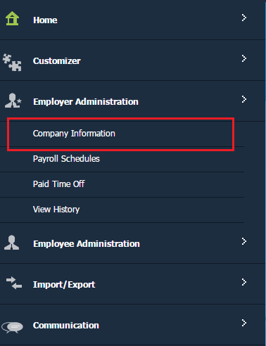
Figure 1: Company Information menu
- Here we can customize the Fiscal Year Start Month, Fiscal Year Start Day, Fiscal Year End Month and Fiscal Year End Day as shown in Figure 2 below

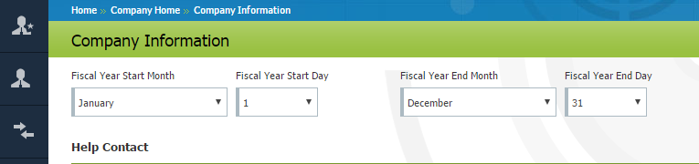
Figure 2: Fiscal year customization on Company Information

There are two customizations of Fiscal Year considered in the system those are below:
- Calendar Fiscal Year
When the Fiscal Year is set from January 1 to December 31 then it is Calendar Fiscal Year as seen in Figure 2.

- Mid Fiscal Year
Apart from Jan 1 to December 31, any other combination of entire year for e.g. June 1 to May 31 or November 1 to 31st October etc. could be considered as Mid Fiscal Year.

For this document we shall consider Calendar Fiscal Year.

Fiscal year implementation is done for the following:
- Age Band changes.
- Employee salary changes.
- Reduction schedule for the coverage.

Fiscal Year Implementation for Age Band changes

Employee Age Band Switch
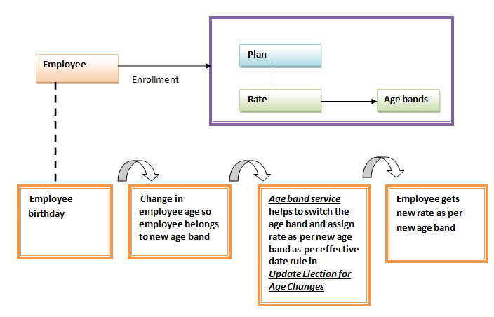
Figure 3: Employee getting new rate as per new age band

- In the WORKTERRA Application, Plans and Rates are configured first, and then rates and plans belonging to the same benefit template are mapped. After the employee enrolled in a plan, the employee gets the rate mapped to that plan.
- Here we are considering Rates configured with age bands such as below:

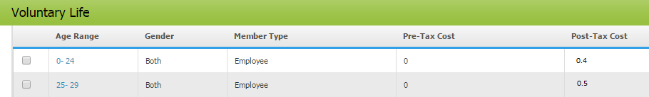
Figure 4: Rate with Age Bands

- The age band service switches the age band for the employee as per option selected on Update Elections for Age Changes in General Plan Design Tab
(Add/Change Plan Design ->Life /LTD Plan Selection->General Plan Design).

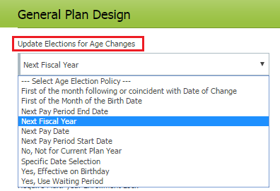
Figure 5: Next Fiscal Year Rule in Update Elections for Age Changes

Prior to Fiscal Year implementation

Requirement
When the age band of the employee changes and the employee gets new rate, this switch of employee age band to get new rate must happen from January 01 Next Year (consider the Next Year as the Year 2018).
- Example of the requirement
Employee Birthday – 10th March 1992.
Rate:
Age | Rate
19-24 | 0.4 $
25-29 | 0.5 $

So consider employee turns 25 years at 10th March 2017 and according to 25-30 Age band he/she should get Rate 5$.
This new rate of 5$ must be applicable from 01/01/2018 and not from 10th march 2017.

- Approach to achieve the requirement

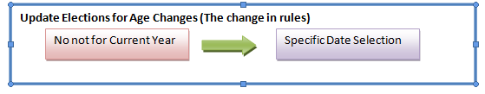
Figure 6 : Change of rules on Update Elections for Age Changes

- For the entire year the Update Elections for Age Changes is set to the effective date rule No not for Current Year and during Open Enrollment period this rule is changed to Specific Date Selection 01/01/Next Year.

- For the employee mentioned, during his/her birthday on 10th March 2017 the rate does not change it changes from 01/01/2018.

- Possible errors in this approach

- It is possible that once the rule is set to No not for Current Year it is not updated to the Specific Date Selection rule.

- In such case the switch in employee age band will not happen even when expected.

Fiscal Year Implementation for Age Changes

To avoid confusions and errors as mentioned in the above section Fiscal Year implementation were done for age changes. Instead of setting effective date rule No Not for Current Year the rule and then changing to Specific Date Selection the rule is directly set to Next Fiscal Year.

Here two configurations are required:
- Setting Calendar Fiscal Year in Company Information as seen in Figure 2.
- Selecting Next Fiscal Year option for Update Election for Age Changes.

According to this rule before Open enrollment period , the employees with age band changes are captured and once the Open enrollment starts the age bands of these employees are switched, and they get new rate as per new age band from 01/01/Next Year

Age band Service behavior for Next Fiscal Year Rule

Before Open enrollment period
If the Age Band service encounters employees with birthdays and age band change, it does not switch the age band for new rate immediately; all this data is maintained in the system till OE first date.

Open enrollment Period
During first date of open enrollment period the service switches the age band of the respective employees and they avail the new rate from 01/01/Next Year.

- The service also makes sure that all the employees who have their birthdays during the enrollment period and after the enrollment period avail the new rate from 01/01/Next Year.
- This ensures that all the employees with age band change will get the new rate as per 01/01/Next Year.

SA Utility behavior for Fiscal Year Age Band Changes

- The age band service for Fiscal Year switches the age bands during the first day of open enrollment period.
- So for this switch to happen it is required to wait till Open enrollment Period.

Requirement
The switch in age band to take place before Open Enrollment Period first day and employee should avail the new rate from 01/01/Next Year.

For example, WORKTERRA Client has Open Enrollment from 15th November to 30th November. So Age Band service for fiscal year will execute on 15th November and switch the age band for new rate changes.
But here the Workterra Client requires the age band switch to happen on 13th November that is before OE Period. This requirement is achieved with the help of SA Utility.

Approach for the requirement
SA Utility executes the age band service for Fiscal Year and switches employee age bands for new rate and all these employees get the new rate from 01/01/Next Year.

Fiscal Year Age band Changes for OE component

While moving the company set up from Stage environment to Production environment the OE Set up Component will execute the age band service for Fiscal Year and help switch the age band for new rate.
This ensures the respective employees get new rate from 01/01/Next Year.

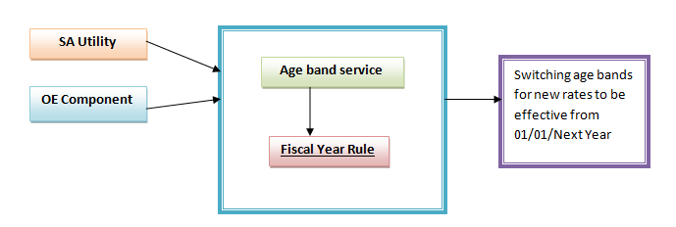
Figure 7: Fiscal Year implementation for SA Utility and OE Component

Fiscal year behavior with different dates (for Age Band Changes)

In this section we have how fiscal year behaves for different dates and when does the employee avail the new rate.
Fiscal Year Start Date - 1 January Fiscal Year Start Date - 31 December
OE Start Date- 15 November 2017 OE End Date -31 November 2017

Calculate Plan Cost On - Fiscal Year Start Date (This flag decides that age is to be considered as per Fiscal Year Start Date)

Rates:-
Age | Rate
19-24 | 0.4 $
25-29 | 0.5 $
30-34 | 0.6 $

Today’s Date | Event | Employee  Birth date | Event Effective Date | Fiscal Year Behavior | SA Utility ,OE Component behavior
17 November 2017 | OE | July 1 1987 | Jan 1 2018 | Employee is electing for first time from 1/1/2018.  As employee is in OE period, next fiscal year will be considered as 1/1/2018 and employee will get age band of 30-34  1/1/2018 - 12/31/2018 (30-34) and rate 0.6$
15 November 2017 | OE | July 1 1987 | Jan 1 2018 | Employee‘s existing election is from 1/1/2016 with cost 0.5$ as of 25-29 age bands.  On OE first day, midnight service will execute and change cost to 0.6$ effective from 1/1/2018 and consider age band 30-34.  1/1/2016 - 12/31/2017 (25-29)  1/1/2018 - 12/31/2018 (30-34) | For existing election, no need to wait till OE start date for mid night service execution.  - On Stage environment SA Utility option executes the Age Band Service for Fiscal Year and new rates get applied from 01/01/Next Year.  - On Production environment, OE Component will execute the service while moving set up from stage to production.  - For clients, who do not ask development team to move OE set up, there is a provision of SA Utility option to execute Age Band service for Fiscal Year on Production Environment as well.
1 April 2017 | Qualifying Event | July 1 1987 | April 1,2017 | Employee is electing from 4/1/2017 with cost as of 25-29 age band because age calculated as of 1/1/2017.  Then On OE first day, midnight service will execute and change cost to 1/1/2018 and will give cost as of age band 30-34.  4/1/2017 - 12/31/2017 (25-29)  1/1/2018 - 12/31/2018 (30-34)
1 December 2017 | New Hire | 15 Dec 1987 | December1, 2017 | Employee is electing from 12/1/2017 with cost as of 25-29 age band.  On 15th December 2017 midnight service will execute and change cost to 1/1/2018 and will give cost as of age band 30-34.  12/1/2017 - 12/31/2017 (25-29)  1/1/2018 - 12/31/2018 (30-34)
1 January 2018 | New Hire | July 1, 1988 | Jan 5, 2018 | Employee is electing from  Jan 1 2018.  Age calculate as of 1/1/2018  5/1/2018 - 12/31/2018 (25-29)

Table 1: Fiscal Year behavior for different dates for Age Band Changes

Fiscal Year implementation for Salary Changes
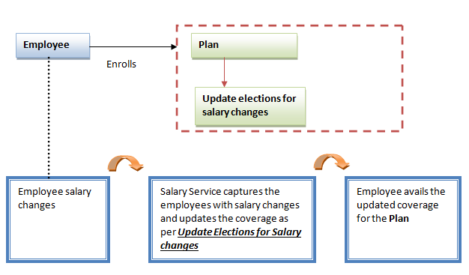
Figure 8: Employee availing updated coverage based on Salary changes
Requirement
The coverage of the employees who have a salary change must update from 01/01/Next Year.
(Here we are considering the coverage is updated as per change in salary).

Fiscal Year customizations for Salary changes:
- Selection of Calendar Fiscal Year in Company Information as seen in Figure 2.
- Selection of Next Fiscal Year Rule in Plan as seen in Figure 9 below.
(Add/Change Plan Design ->select Life/LTD plan ->General Plan Design tab)

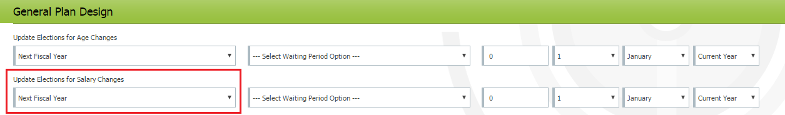

Figure 9: Fiscal Year customization for Salary change in the Plan

Salary service behavior for Next Fiscal Year Rule

Before enrollment period
When the salary service encounters the employees with change in salary (here change in salary could be increase in salary or decrease in salary the most recently updated salary is considered), the service does not update the coverage immediately, all this data is stored into the system till OE first date.

Open enrollment Period
During first date of open enrollment period the service updates the coverage for the respective employees whose salaries got changed and they avail the new coverage from 01/01/Next Year.

- The service also makes sure that all the employees who have their birthdays during the enrollment period and after the enrollment period avail the updated coverage from 01/01/Next Year.
- This ensures that all the employees who should avail the updated coverage will get the updated coverage as per 01/01/Next Year.

SA Utility behavior for Fiscal Year (Salary Changes for Employee)

- The Salary Service for Fiscal Year updates the coverage of respective employees during the first day of open enrollment period.
- So for this change to happen it is required to wait till Open enrollment Period.

Requirement
The update in the coverage is to take place before Open Enrollment Period first day and employee should avail the updated coverage from 01/01/Next Year.

Approach for the requirement
SA Utility executes the Salary service for Fiscal Year and updates the coverage of the employees with salary change from 01/01/Next Year.

Changes in OE Component

- While moving the company set up from Stage environment to Production environment the OE Set up Component will execute the Salary service for Fiscal Year and helps to update the coverage for the employees who had salary changes.
- This ensures the respective employees get new updated coverage from 01/01/Next Year.

Fiscal year behavior with different dates (for Salary Changes)

Fiscal Year Start Date - 1 January Fiscal Year Start Date - 31 December
OE Start Date- 15 November 2017 OE End Date -31 November 2017

Coverage with old salary - 10000$
Coverage with new salary - 12000$

Today’s Date | Event | Salary Change Date | Event Effective Date | Fiscal Year Behavior | SA Utility ,OE Component behavior
17 November 2017 | OE | July 1 2017 | Jan 1, 2018 | Employee is electing in the plan for the first time.  Employee coverage -$12000$ from 1/1/2018.
15 November 2017 | OE | July 1 2017 | Jan 1, 2018 | Employee‘s existing election is from 1/1/2016 with coverage 10000$.  On OE first day, midnight service will execute and switch election to 1/1/2018 and update coverage to 12000$.  1/1/2016 - 12/31/2017 10000$  1/1/2018 - NULL 12000$ | For existing election, no need to wait till OE start date for mid night service execution.  - On Stage environment SA Utility option executes the Salary Service for Fiscal Year and updated coverage gets applied from 01/01/Next Year.  - On Production environment, OE Component will execute the service while moving set up from stage to production.  - For clients, who do not ask development team to move OE set up, there is a provision of SA Utility option to execute Salary service for Fiscal Year on Production Environment as well.
1 April 2017 | Qualifying Event | July 1 2017 | April 4, 2017 | Employee is electing plan from 4/1/2017.  Coverage is 10000$ as salary considered as of 4/1/2017.  Then on first day of OE, midnight service will execute and switch election to 1/1/2018 and update coverage to 12000$.  4/1/2017 - 12/31/2017 10000$  1/1/2018 - NULL 12000$
1 June 2017 | New Hire | July 1 2017 | December 1, 2017 | Employee‘s existing election is from 6/1/2016 with 10000$ coverage.  In OE setup, midnight service will execute and switch election to 1/1/2018 and update coverage to 12000$.  6/1/2017 - 12/31/2017 10000$  1/1/2018 – NULL 12000$
1 January 2018 | OE | July 1 2017 | Jan 5, 2018 | Employee’s existing election is in the plan from 1/1/2016 with 10000$ coverage.  Salary update is as of 1/1/2018.  From 1/1/2018 election will get updated coverage 12000$.  1/1/2016 - 12/31/2017 10000$  1/1/2018 - NULL 12000$

Table 2: Fiscal Year behavior for Salary Changes

Fiscal Year Implementation for Reduction Schedule
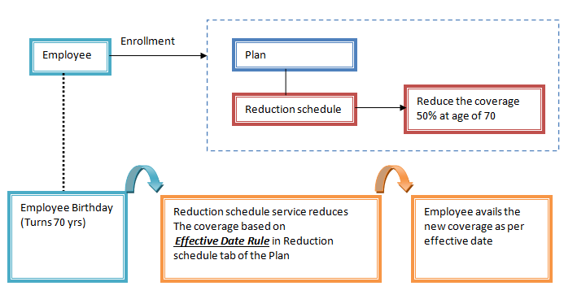
Figure 10 : Employee availing the reduced coverage
Requirement
The reduction in the coverage of the employees, who have attained the age required for coverage reduction, should happen from 01/01/Next Year.

Fiscal Year customization for Reduction schedule

1. Selection of Calendar Fiscal Year in Company Information as seen in Figure 2.
2. Selection of Next Fiscal Year Rule in Reduction Schedule tab of Life/LTD Plan. (Figure 11)

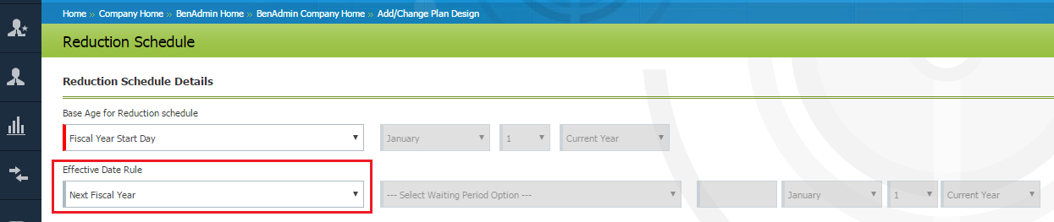

Figure 11: Fiscal Year Rule in Reduction Schedule Tab

Reduction Schedule Service behavior for Next Fiscal Year Rule

Before Open enrollment period
When the reduction schedule service encounters employees with birthdays and change in coverage, it does not update the reduced coverage; all this data is maintained in the system till OE first date.

Open enrollment Period
During first date of open enrollment period the service updates the reduced coverage for the respective employees and they avail the new reduced coverage from 01/01/Next Year.

- The service also makes sure that all the employees who have their birthdays during the enrollment period and after the enrollment period avail the new reduced coverage from 01/01/Next Year.
- This ensures that all the employees who should avail the reduced coverage will get the new coverage as per 01/01/Next Year.

SA Utility behavior for Fiscal Year (for Reduction Schedule)

- The Reduction schedule service for Fiscal Year updates the reduced coverage of respective employees during the first day of open enrollment period.
- So for this change to happen it is required to wait till Open enrollment Period.

Requirement
The availability of reduced coverage is to take place before Open Enrollment Period first day and employee should avail the updated coverage from 01/01/Next Year.

Approach for the requirement
SA Utility executes the Reduction Schedule Service for Fiscal Year and updates the coverage of the employees from 01/01/Next Year.

Reduction Schedule changes for OE component

While moving the company set up from Stage environment to Production environment the OE Set up Component will execute the reduction schedule service for Fiscal Year and helps to update the reduced coverage for the employees.
This ensures the respective employees get new reduced coverage from 01/01/Next Year.

Fiscal Year behavior with different dates (for Reduction Schedule)

In this section we have how fiscal year behaves for different dates and when does the employee avail the new coverage.
Fiscal Year Start Date - 1 January Fiscal Year Start Date - 31 December
OE Start Date- 15 November 2017 OE End Date -31 November 2017

Coverage reduced to 50% when employee attains 65 years of age.

Initial Coverage 10000$
Reduced Coverage 5000$
Today’s Date | Event | Employee  Birth date | Event Effective Date | Fiscal Year Behavior | SA Utility ,OE Component behavior
17 November 2017 | OE | July 1, 1952 | Jan 1, 2018 | Employee is electing plan for first time.  So employee coverage is 5000$ from 1/1/2018
15 November 2017 | OE | July 1, 1952 | Jan 1, 2018 | Employee’s existing election is from 1/1/2016 with coverage 10000$.  On OE first day, midnight service will execute and switch election to 1/1/2018 and will give coverage as 5000$.  1/1/2016 - 12/31/2017 10000$  1/1/2018 - NULL 5000$ | For existing election, no need to wait till OE start date for mid night service execution.  - On Stage environment SA Utility option executes the Reduction Service for Fiscal Year and gives the reduced coverage from 01/01/Next Year.  - On Production environment, OE component will execute the Reduction Service for Fiscal Year while moving set up from stage to production.  - For clients, that don’t seek development team‘s help to move OE set up, there is provision of SA utility option of Reduction Service for Fiscal Year for execution on Production environment as well.
1 April 2017 | QE | July 1, 1952 | April 1 2017 | Employee election in the plan is from 4/1/2017.  Employee gets $10000 coverage as age is calculated as of 1/1/2017.  In OE, midnight service will execute and switch election to 1/1/2018 and will update coverage to 5000$.  4/1/2017 - 12/31/2017 10000$  1/1/2018 - NULL 5000$.
1 December 2017 | New Hire | Dec 15, 1952 | December 1,2017 | Employee election in the plan is from 12/1/2017.  Employee Coverage - 10000$.  On 15th December 2017, service will execute and switch election to 1/1/2018 and will update coverage 5000$  12/1/2017 - 12/31/2017 10000$  1/1/2018 - NULL 5000$
1 January 2018 | New Hire | July 1 ,1953 | 1/5/2018 | Employee plan election is from 1/5/2018 with the coverage 10000$.  Age calculate as of 1/1/2018  5/1/2018 - NULL 10000$
Table 3: Fiscal Year behavior with different dates for Reduction Schedule

Fiscal Year implementation in other areas
Rates:
- Calculate Plan Costs On

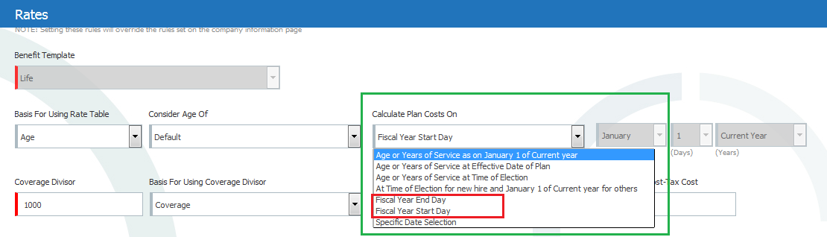
Figure 12: Rates - Calculate Plan Cost on (Fiscal Year options)

Here we have two options in the dropdown of Calculate Plan Costs On as highlighted in Figure 12.
- Fiscal Year End Day
When employee enrolls in the plan with this rate (Fiscal Year End Date customization) the age of the employee is considered as per age Fiscal Year End Date.

Example
Fiscal Year End Date - 31st December
Employee birthday 10 March 1992
25-30 Age the Rate is 5$.

If Fiscal Year End Date is 31st December 2017 and as per this date employee’s age is 25 years then the cost for this plan is calculated as per the rate customized for 25 years.
So the employee gets the rate 5$.

- Fiscal Year Start Day
When employee enrolls in the plan with this rate (Fiscal Year Start Date customization) the age of the employee is considered as per age Fiscal Year Start Date.

Example
Fiscal Year Start Date - 1st January.
19-24 Age the Rate is 4$.
25-29 Age the Rate is 5$.

If Fiscal Year Start Date is 1st January 2017 and as per this date employee’s age is 24 years then the cost for this plan is calculated as per the rate customized for 24 years.
So the employee gets the rate 4$.

Reduction Schedule

- Base Age for Reduction

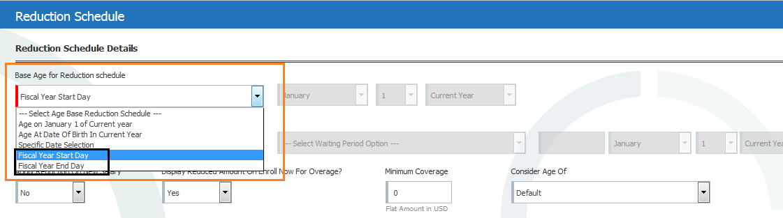
Figure 13: Fiscal Year options in Base Age for Reduction Schedule

Here we have two options in the dropdown of Base Age for Reduction Schedule as highlighted in Figure 13.

- Fiscal Year End Day
The age of the employee to be considered for reduction schedule is considered through this flag.
When employee enrolls in the plan with Fiscal Year End Date customization the age of the employee is considered as per age Fiscal Year End Date.

- Fiscal Year Start Day
When employee enrolls in the plan with Fiscal Year Start Date customization the age of the employee is considered as per age Fiscal Year End Date.

    - For e.g. if Fiscal Year Start Date is 1st January and employee’s age is 65 years as of this date and the employee is eligible for reduction schedule at this age ,then the employee gets reduced coverage for this plan .
    - The employee will avail the reduced coverage as per Effective Date Rule set in Reduction schedule as seen in Figure 11

